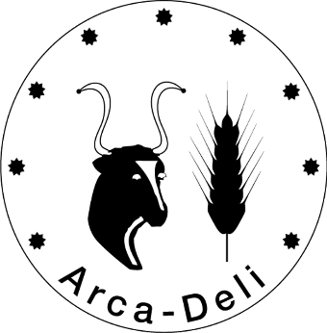
Application for the
Arca-Deli Award 2026
Information and Declaration Sheet

I hereby apply for the Arca-Deli Award 2026:
Given name |  |  | Farm/Company
Surname |  |  | Address
e-mail |  |  | Postal Code
Phone |  |  | City
Website |  |  | Country

Are you registered on Arca-Net? | ☐ Yes | ☐ No
Name and type of product submitted or service offered (e.g. cheese, grazing project, bag, ...)

Please note: A product can only be entered for the Arca-Deli Award once, reapplication in subsequent years is excluded.

Please provide further details that can be used for publication (e.g. newsletter, website, social media).

Detailed description of product/service

continue on page 2 →
Description of the livestock breed / plant variety
Description of the farm/company/institution

I hereby declare that my entry fulfils the following conditions:
- The livestock and/or cultivated plants belong to an autochthonous breed or variety of my region
- The production is local and not industrialised
- Livestock and/or cultivated plants are of value for the local cultural heritage
- No GMOs have been used
- Livestock is purebred and kept according to documented traditional husbandry methods and complies with applicable animal welfare regulations (EU regulation or national law).

Place, date |  |  | Signature

Together with your application please provide 2 to 4 pictures of each the product and the breed/variety in digital format that can be used for publishing. Please send the signed application form to: office@save-foundation.net

